**Reg. No. 21BCE1297 Name: Vidhi Shah Date of Practical: 02/03/22**

**Experiment 2**

**Aim:**

* I-V Characteristics of diode and zener diode.
* Transient analysis of diode for AC source.

**Tools and Apparatus:**

* ­LTSpice
* Diode
* Zener Diode
* Resistor
* AC/DC Source

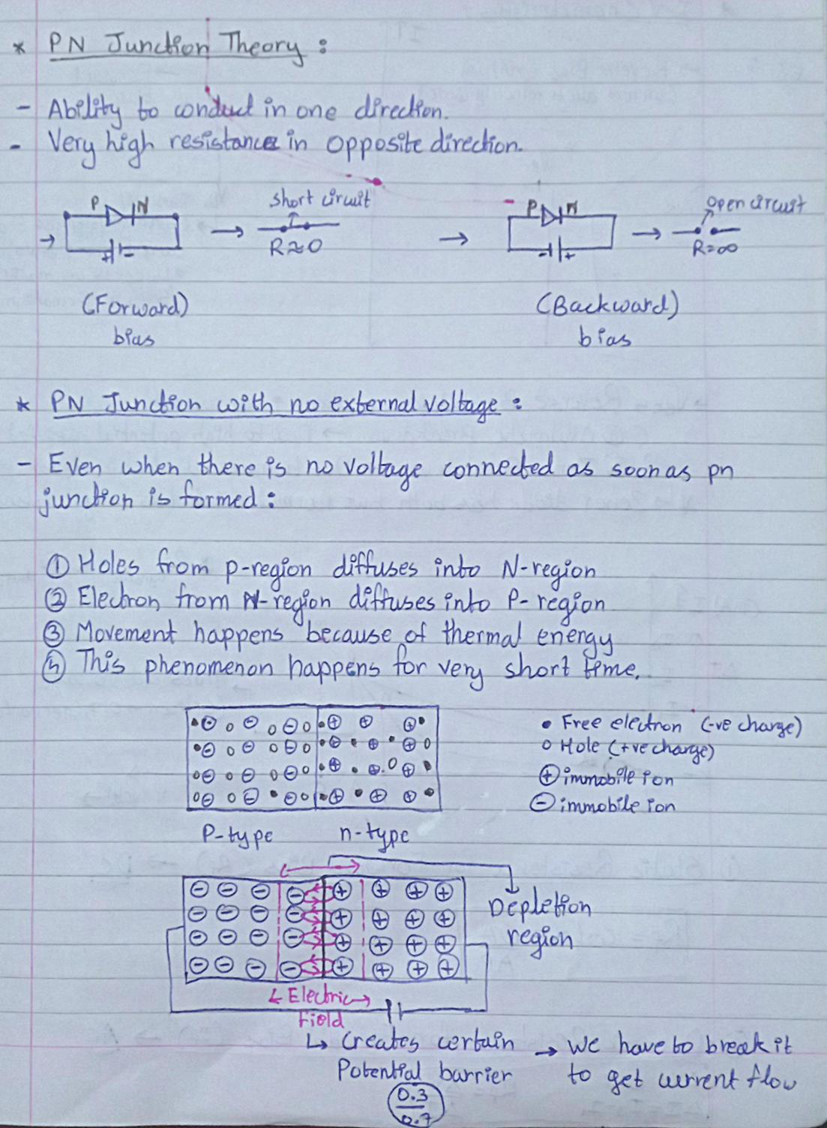**Theory and Design:**

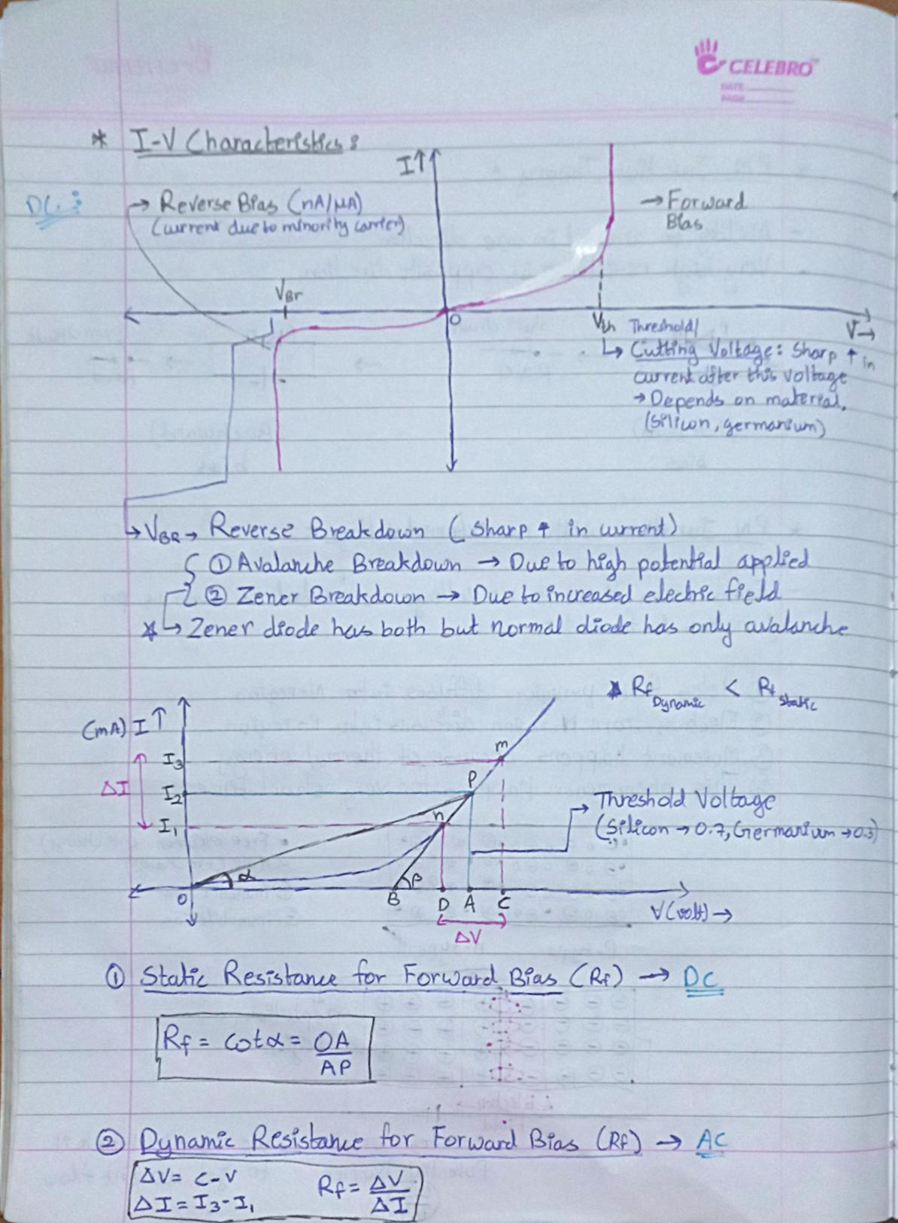



**Simulation Results:**

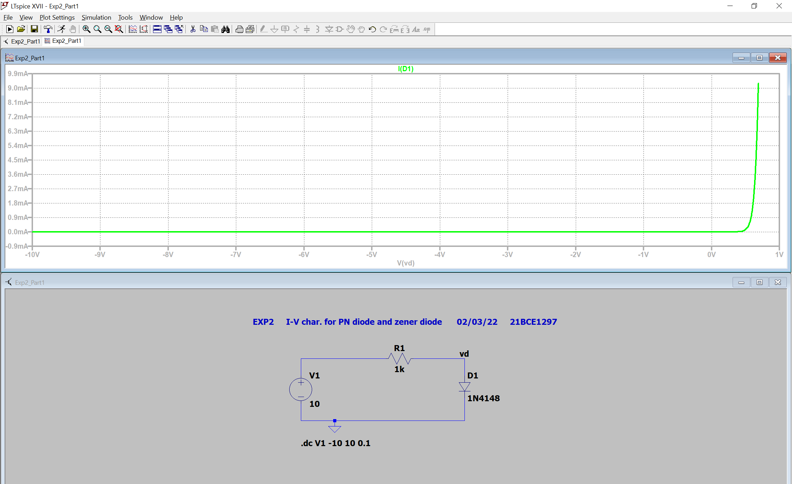1) Forward Bias

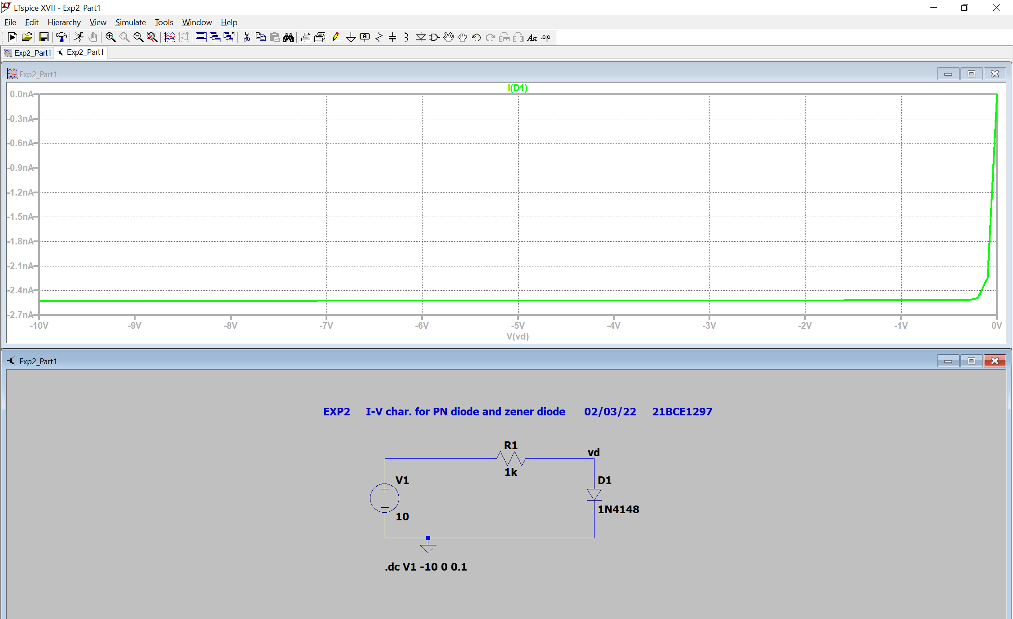2) Reverse Bias

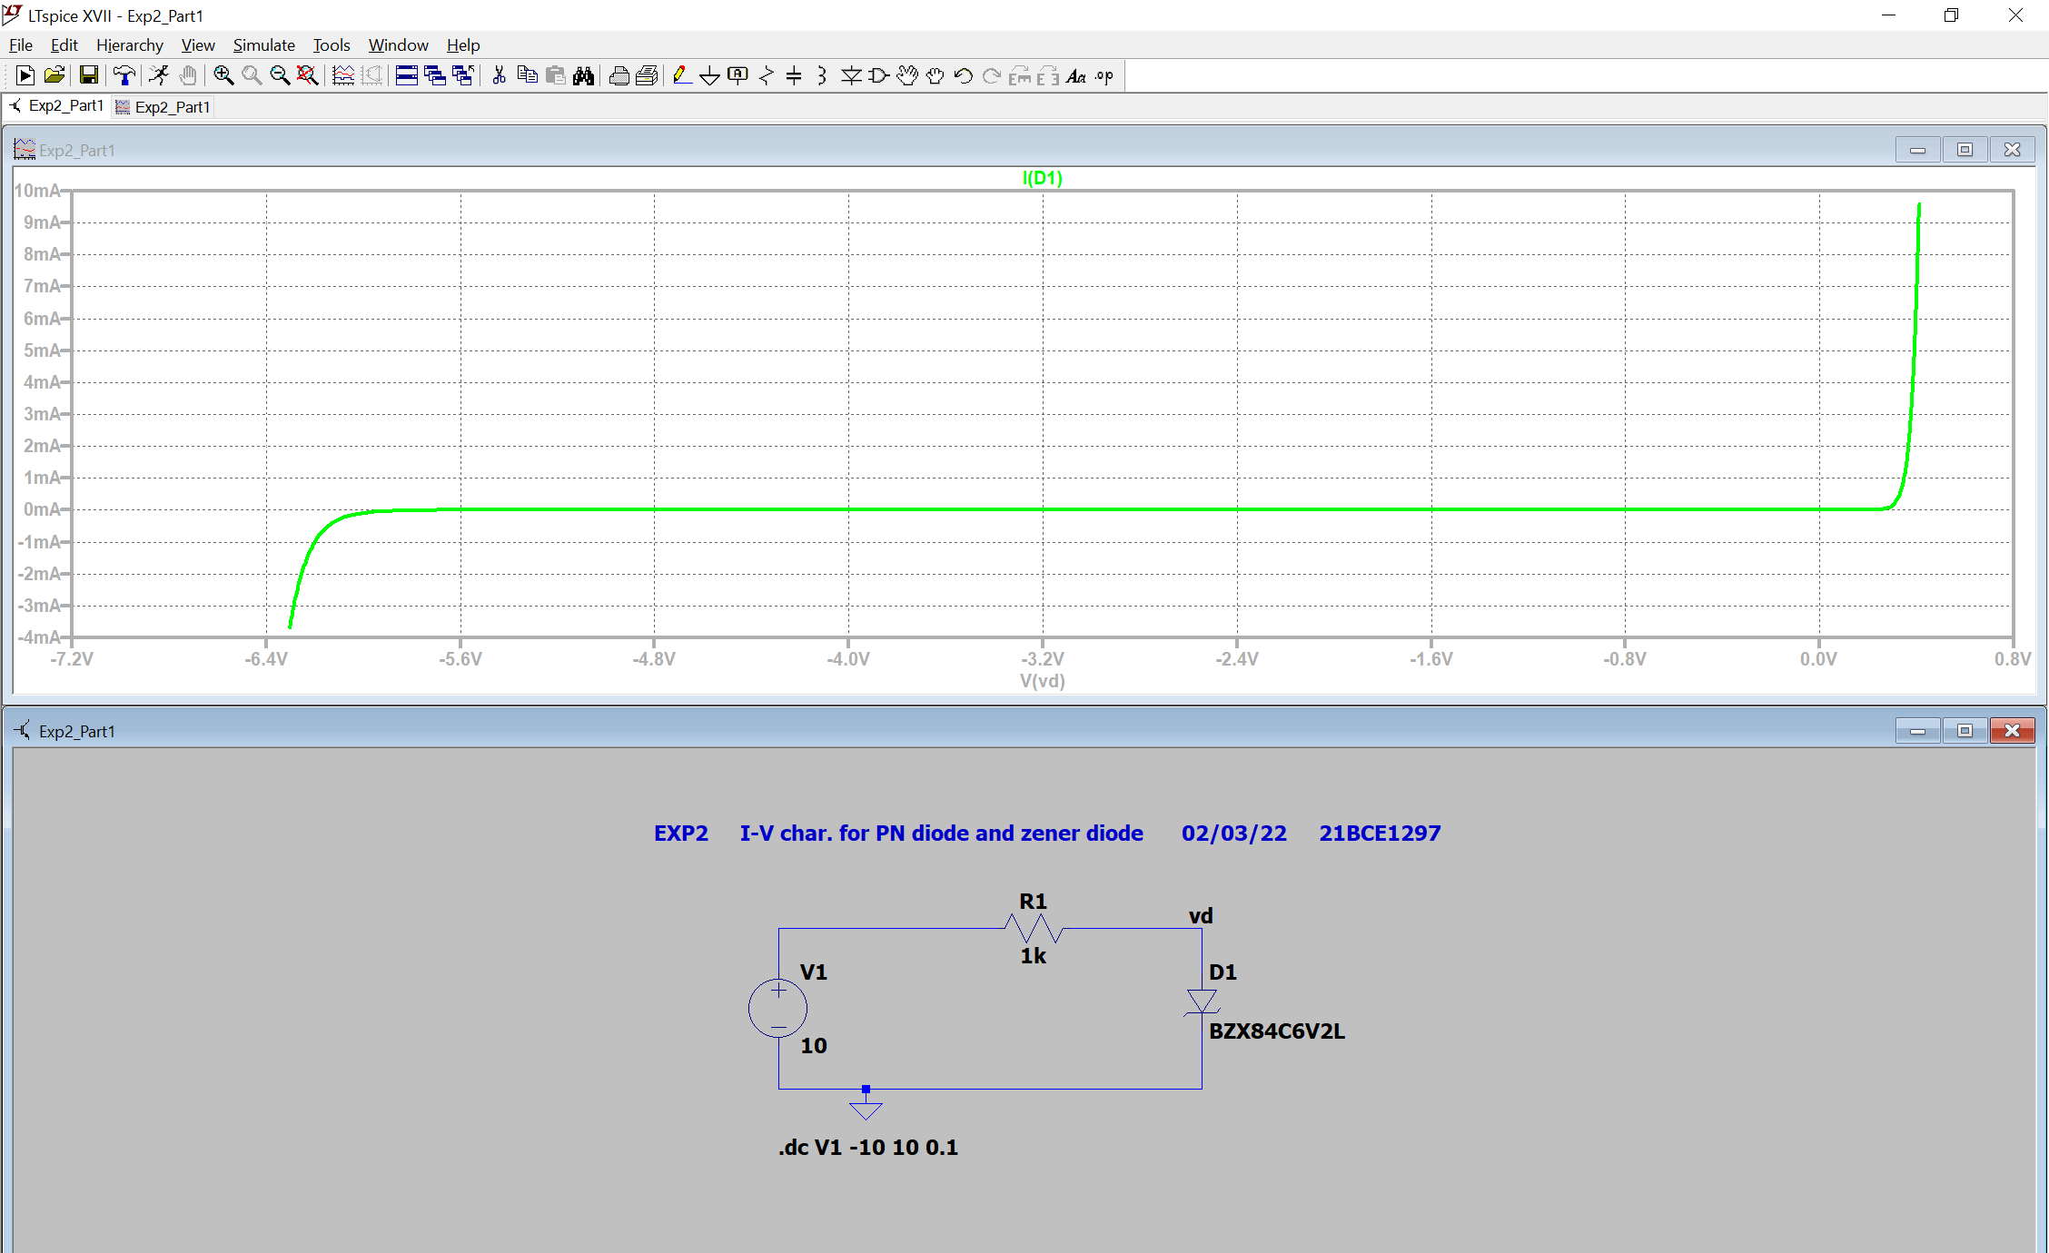3) Zener Diode

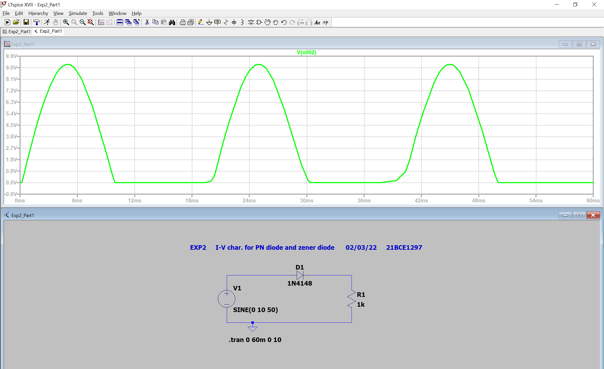4) Transient Analysis

**Conclusion:**

$$V=560 mv$$

$$I=600 μA$$

$Static Resistance=\frac{560 × {10}^{-3}}{600 × {10}^{-6}}=933.33 Ω$

**Inferences:**

* Threshold voltage and breakdown voltage for zener diode is clearly visible.
* In transient analysis output is (10V - Threshold Voltage). So it is around 9.3V as threshold voltage is around 0.7 V.
* For static resistance calculate ratio by taking values from linear region and NOT exponential region.
* Label vd properly.